- 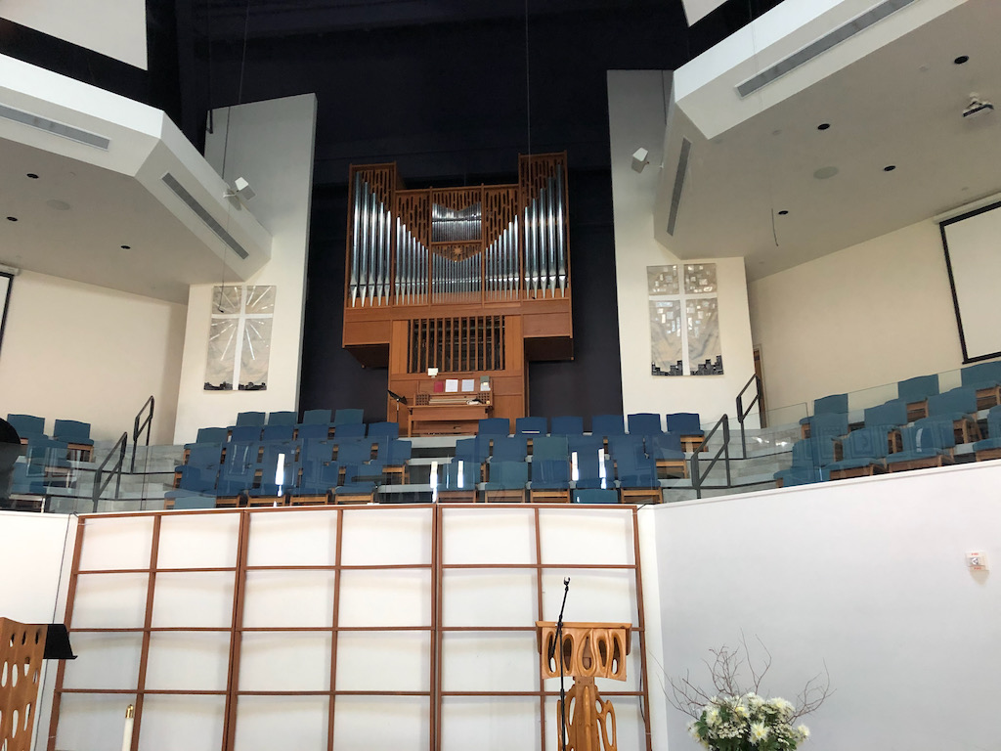
Music is the pre-eminent language of corporate worship. Northaven has a long history of worship music and a heritage of faithful and talented church musicians, both lay and professional. Our corporate worship is a treasure—this treasure exists only when music sounds forth in time and when human beings are able to make music with a body, mind, spirit, and voice, because worship is enriched and enlivened when celebrated joyfully in song.
For more than a thousand years, the pipe organ has been the foundation of this musical tradition. Its richly varied tone colors and sustained tone make it uniquely capable of supporting congregational singing and filling a space with music. Its rich sound allows the mind to bypass more temporal tunes and distractions and instead, be lifted to the praise of God.
Why is the organ the most effective instrument for this purpose? Because organ pipes are designed to support the human voice. The clarity and intensity of the pipe organ (not necessarily the volume) generated without electronic amplification effectively inspires song. Unlike amplified sound coming at the assembly through speakers, the organ quite literally surrounds the assembly with ample sound via air moving through pipes – just like the human voice.
The organ also mimics other musical sounds – trumpets, oboes, strings, and flutes – which are at the fingertips of the organist to enhance musical worship. The instrument’s resonance, expression, and capacity to sustain singing in worship remind us of the immensity and the magnificence of God.
Our organ was designed, built, and installed in 1973 (in our former Sanctuary on the same property) by Roy Redman. It was his Opus 7. When the current sanctuary was built (2004) , the organ was updated and installed in its current home. Our organ consists of two manual keyboards, pedal keyboard, and 36 ranks (36 rows of pipes), representing 27 different qualities of pitch and tone which can be combined in hundreds of ways. The organ is a mechanical action (tracker) instrument—meaning that the movement of the keys is directly linked to valves under the pipes, admitting air and making the sound. We are also fortunate that our builder, Roy Redman, is an active organ builder, and handles the tuning and maintenance of our organ.
Northaven’s organ owes a great deal to the influence of Jane and Elbert Marshall. Jane Marshall (1924-2019), reknowned church musician and composer, served as Organist and Music Director for many years, and was the moving force behind the acquisition of our organ. Her spouse Elbert Marshall (1924-2021), an engineer, was instrumental in the design, installation, re-installation, and ongoing care for the organ.
Our current organist, Larry McCain, is happy to ‘Show and Tell” anyone interested in learning more about our beautiful organ. Also, see information from the Organ Historical Society
https://pipeorgandatabase.org/organ/7061

Dallas, Texas
Northaven United Methodist Church

Roy A. Redman Opus 7 1973
2 manuals, 27 stops, 36 ranks
___________________________________________

GREAT ORGAN (2½" wind pressure)
16' Holzquintada 61
8' Prinzipal 98 *
8' Rohrflöte 61
4' Octave 61
4' Holzflöte 61
2 2/3' Quinte 61
2' Waldflöte 61
1 3/5' Terz 61
1 1/3' Mixture IV 244
8' Trompete 61
16'Trompette 61
Tremulant
Zimbelstern
* doubled from c25

SWELL ORGAN (2" wind pressure)
8' Holzgedackt 61
8' Weidenpfeife 61
8' Schwebung (t.c.) 49
4' Prinzipal 61
4' Spillflöte 61
2' Octave 61
1 1/3' Nasat 61
2/3' Scharf IV 244
8' Krummhorn 61
Tremulant

PEDAL ORGAN (3" wind pressure)
16' Subbass 32
8' Prinzipal 32
8' Bleigedackt 32
4' Octave 32
2' Mixture IV 128
16' Fagott 32
8' Trumpet 32

COUPLERS
Swell-Great
Swell-Pedal
Great-Pedal

